SMART EMERGENCY PATIENT COORDINATION SYSTEM
Project Report
CSA0203 – C Programming
Presented by:
V. Vijay (192525264)
A. Guna Sekar (192525302)
P V Rahul Kavi (192571090)
September 2026

1. Introduction
Hospitals often receive patients from multiple registration counters at the same time, especially during emergencies. Each patient record carries critical information such as the patient ID, emergency level, symptoms, assigned doctor, and treatment status. Because several departments may need to access or update the same patient record simultaneously, there is a real risk of data conflicts, lost updates, incorrect information, and record corruption if the system is not designed carefully.
The Smart Emergency Patient Coordination System is a C-based application developed to address this challenge. It centralizes patient record management and coordinates the flow of information between hospital departments, while protecting shared data from concurrent-access errors. The project applies core C programming concepts — structures, dynamic memory allocation, functions, pointers, multithreading, mutex-based synchronization, inter-process communication (IPC), and file handling — to build a working simulation of a real hospital emergency workflow.
In a real emergency department, every second matters. A coordination system that loses updates or serves stale information to a doctor or pharmacist can directly delay patient care. This project therefore treats data integrity and concurrency safety as first-class design goals rather than an afterthought, and builds the system around them from the ground up.

Motivation
The motivation for this project comes from observing how manual or loosely coordinated hospital record-keeping can break down under pressure — particularly during mass-casualty events or peak hours when many patients arrive together. A lightweight, well-synchronized software layer, even a console-based one built in C, demonstrates how systems-level programming concepts can solve a genuinely practical coordination problem.

2. Problem Statement
In a typical hospital environment, patients are registered from multiple counters simultaneously, and their records are subsequently accessed by different departments — emergency/triage, doctors, pharmacy, and discharge — often at the same time. Without a coordinated system, this concurrent access leads to several problems:
- Data conflicts between departments updating the same record at the same time
- Lost updates when simultaneous writes overwrite each other
- Incorrect or inconsistent patient information across departments
- Record corruption caused by unsynchronized access
- No reliable audit trail of what changed, when, and by which department
These issues can directly affect the speed and safety of emergency patient care, making a reliable coordination mechanism essential. The problem is fundamentally a concurrency and data-integrity problem: multiple independent actors (departments) need read/write access to a shared resource (the patient record) without corrupting it or seeing an inconsistent view of it.

3. Objectives
- Develop a reliable emergency patient coordination system.
- Dynamically allocate memory for patient records so the system scales with actual patient load.
- Use functions to modularize patient operations (register, search, update, discharge).
- Use pointers to access and modify records efficiently without unnecessary copying.
- Use threads to simulate the concurrent operation of hospital departments.
- Use mutexes to ensure safe concurrent updates to shared data and prevent race conditions.
- Use inter-process communication (IPC) to pass emergency information between modules.
- Store patient history in files for future reference, auditing, and continuity of care.

4. Existing System and Limitations
Many small and mid-sized hospitals still rely on paper-based registers or simple, non-concurrent digital logs for tracking emergency patients. Even where digital systems exist, they are frequently designed for single-user, single-counter operation and are not built to handle multiple departments reading and writing the same record at the same time.
- Paper-based logs are slow to search and prone to human transcription errors.
- Single-user desktop tools do not support real concurrent access from multiple counters or departments.
- Without synchronization, simultaneous updates can silently overwrite each other.
- Manual systems have no automatic audit trail of who changed what and when.
- Static, fixed-size record arrays waste memory or run out of capacity during high patient inflow.
These limitations directly motivate the proposed system's emphasis on dynamic memory allocation, thread-based department simulation, and mutex-protected record updates.

5. Proposed System
The proposed system centralizes patient record management so that multiple hospital departments — Registration, Emergency/Triage, Doctor/Treatment, Pharmacy, and Discharge — can work with patient data simultaneously without conflict. It provides real-time coordination between departments, protects patient records during updates, and maintains a complete history for every patient from registration through discharge.

Departments Covered
- Registration – captures new patient details from one or more counters
- Emergency/Triage – assesses and updates emergency level, flags critical cases
- Doctor/Treatment – assigns doctors and updates treatment status
- Pharmacy – records medicines provided and updates medication status
- Discharge – finalizes treatment status and closes patient records

Design Goals
- Correctness — no lost updates or corrupted records under concurrent access
- Efficiency — minimal memory overhead via dynamic allocation and pointer-based access
- Traceability — every meaningful event is written to the patient history file
- Modularity — each operation is implemented as an independent, reusable function

6. System Requirements

Hardware Requirements
Component | Minimum Requirement
Processor | Dual-core, 1.6 GHz or higher
RAM | 2 GB or higher
Storage | 100 MB free disk space (for source, binary and history files)

Software Requirements
Component | Requirement
Operating System | Windows / Linux
Language | C (C99 or later)
Compiler | GCC (with pthread support)
Libraries | stdio.h, stdlib.h, string.h, pthread.h

7. Patient Data Management
Patient data management forms the core of the system and is built around four key C programming concepts:

C Structures
A structure stores the complete patient record in one unit, including patient ID, emergency level, symptoms, assigned doctor, and treatment status. Grouping related fields into a single structure keeps every function's interface simple — a function can accept or return one patient record instead of many separate parameters.
typedef struct {
int patientID;
char name[50];
char symptoms[100];
int emergencyLevel; // 1 = Critical, 2 = Serious, 3 = Stable
char assignedDoctor[50];
char treatmentStatus[30];
} Patient;

Dynamic Memory Allocation
Memory for patient records is allocated dynamically as new patients are registered, allowing the system to scale without a fixed, wasteful upper limit. When the number of patients grows beyond the current capacity, the array of patient records is resized using realloc().
Patient *patients = NULL;
int patientCount = 0, capacity = 0;
if (patientCount == capacity) {
capacity = capacity == 0 ? 10 : capacity * 2;
patients = realloc(patients, capacity * sizeof(Patient));
}

Core Functions
Dedicated functions handle Register, Search, Update, and Discharge operations, keeping the codebase modular and easy to maintain and test independently.
- registerPatient() – adds a new patient record
- searchPatient() – locates a record by patient ID
- updatePatient() – modifies emergency level, doctor, or treatment status
- dischargePatient() – marks a patient as discharged and archives the record

Pointers
Pointers are used throughout to access and modify patient records efficiently without unnecessary copying of data, making operations faster and more memory-efficient. Passing a pointer to a Patient structure lets a function modify the original record directly rather than working on a temporary copy.
void updateStatus(Patient *p, const char *status) {
strncpy(p->treatmentStatus, status, sizeof(p->treatmentStatus) - 1);
}

8. System Architecture
The architecture diagram below illustrates how registration counters, the IPC module, the patient management module, mutex synchronization, hospital department threads, and file-based storage work together.
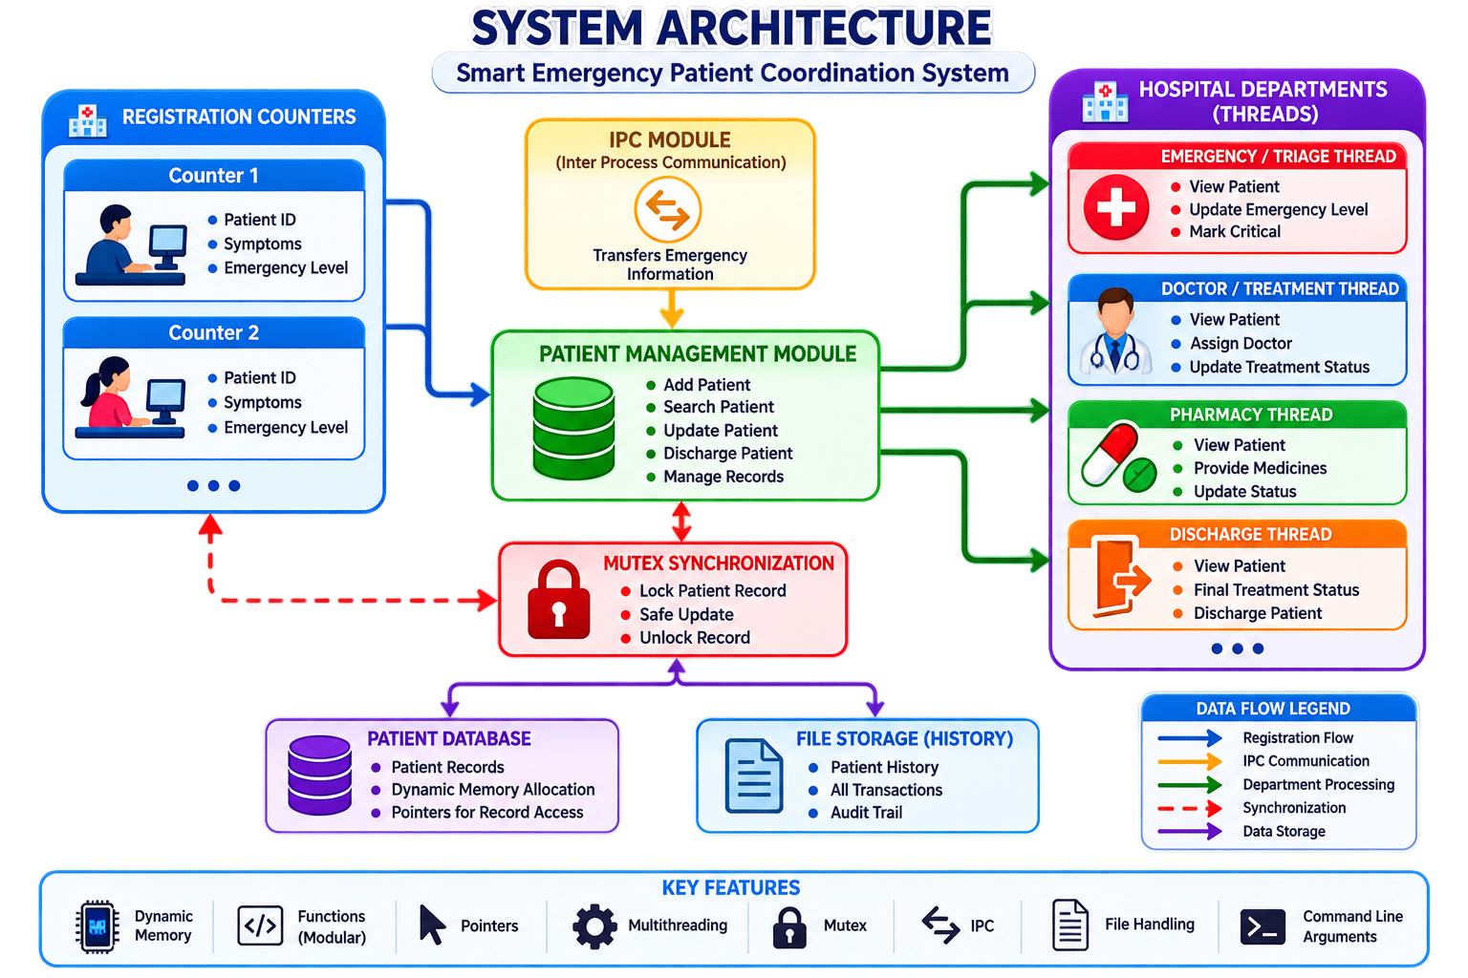
Registration counters feed new patient data into the Patient Management Module, which exposes Add, Search, Update, and Discharge operations backed by dynamically allocated, pointer-accessed records. The IPC module transfers emergency information between registration and treatment, mutex synchronization protects each record during updates (lock, safe update, unlock), and the hospital departments operate as separate threads that each view, update, and process patient records. All activity is persisted to file-based patient history for auditing.
Data flows through the system in five patterns, shown in the diagram's legend: the registration flow (blue) from counters into the management module, IPC communication (orange) carrying emergency data to the treatment side, department processing (green) from the management module out to each department thread, synchronization (red, dashed) between departments and the mutex lock, and data storage (purple) into the patient database and file-based history.

9. Multithreading and Synchronization
Each hospital department — Emergency/Triage, Doctor/Treatment, Pharmacy, and Discharge — is simulated as an independent thread that can view patients and perform its department-specific updates (for example, updating emergency level, assigning a doctor, or marking a patient as discharged).
Because multiple threads may need to update the same patient record at the same time, the system uses a mutex to lock a record before an update, apply the change safely, and then unlock it. This prevents race conditions, lost updates, and corrupted records while still allowing departments to operate concurrently.
pthread_mutex_t recordLock = PTHREAD_MUTEX_INITIALIZER;
void safeUpdate(Patient *p, const char *status) {
pthread_mutex_lock(&recordLock);
strncpy(p->treatmentStatus, status, sizeof(p->treatmentStatus) - 1);
pthread_mutex_unlock(&recordLock);
}
Each department thread is launched with pthread_create() and runs a loop that waits for new work, acquires the mutex only for the short duration of the actual record update, and releases it immediately afterward — keeping the critical section as small as possible so departments are not needlessly blocked.

10. IPC and File Handling

Inter-Process Communication (IPC)
IPC connects the registration and treatment modules. The registration side sends the patient ID, emergency level, and symptoms, and the treatment module receives this emergency information so that care can begin without delay. This decouples the registration counters from the treatment workflow while still keeping them synchronized.

File Handling
Patient history is stored in a file so that a complete record of each patient's journey is preserved. The stored history includes:
- Registration details
- Emergency-level changes
- Doctor assignment
- Treatment updates
- Discharge information
void logHistory(int patientID, const char *event) {
FILE *fp = fopen("patient_history.txt", "a");
if (fp) {
fprintf(fp, "Patient %d: %s\n", patientID, event);
fclose(fp);
}
}
This file-based history provides a reliable audit trail of all patient activity across departments and allows the system to be reviewed or restored after a restart.

11. Testing
The system was tested using a combination of functional and concurrency-focused test cases to confirm both correctness of individual operations and safety under simultaneous access.
Test Case | Expected Result | Outcome
Register a new patient | Record created with correct ID and details | Pass
Search for existing patient ID | Correct record returned | Pass
Two threads update same record concurrently | No lost update; both changes reflected safely | Pass
Discharge a patient | Status updated and history logged | Pass
Register beyond initial capacity | Memory reallocated without data loss | Pass

12. Advantages of the Proposed System
- Prevents data conflicts and lost updates through mutex-protected record access.
- Scales memory usage dynamically instead of relying on a fixed-size record array.
- Modular functions make the code easy to extend, test, and maintain.
- Multithreaded department simulation reflects real hospital concurrency.
- File-based history gives a complete, reviewable audit trail.
- Lightweight console-based design with no external dependencies beyond the standard C and pthread libraries.

13. Applications
- Emergency departments needing fast, conflict-free patient coordination.
- Hospitals with multiple registration counters operating simultaneously.
- Teaching tool for demonstrating structures, pointers, dynamic memory, threads, mutexes, IPC, and file handling in C.
- Foundation that can be extended into a full hospital information system.

14. Future Scope
- AI-based emergency-level prediction
- IoT-based patient monitoring
- Mobile application for department staff
- SMS and emergency notifications
- Cloud-based hospital integration
- Ambulance tracking
- Advanced analytics on patient flow
- Electronic Health Record (EHR) integration

15. Conclusion
The Smart Emergency Patient Coordination System is a centralized solution for coordinating emergency patient information across multiple hospital departments. By combining dynamic memory allocation, pointers, modular functions, and multithreading with mutex-based synchronization, the system safely supports concurrent access to shared patient records. Inter-process communication links registration and treatment modules, while file handling maintains a complete, auditable patient history. Together, these C programming concepts allow the system to successfully address the coordination challenges of a real hospital emergency workflow, while leaving clear room for future enhancement toward a full-scale hospital information system.

16. References
- Kernighan, B. W., & Ritchie, D. M., The C Programming Language, 2nd Edition, Prentice Hall.
- POSIX Threads Programming — pthread library documentation.
- GNU C Library Reference Manual — dynamic memory management (malloc/realloc/free).
- Standard I/O and file handling reference, C Standard Library documentation.

